Floor Framing

The load transfer of a floor frame is as follows:
- live and dead loads on the flooring system
- flooring supported by floor joists
- joists supported by floor bearers
- bearers supported by timber stumps (or other approved method)
In brick veneer construction engaged masonry piers or a reinforced concrete perimeter footing system will generally support the floor bearers.
- timber stumps on unreinforced concrete footing pads (or timber sole plates)
- footing pads by foundation material (minimum bearing capacity of 100 kPa.)

Flooring systems.
(a) Platform flooring.
This is a flooring system designed to be fixed as a continuous platform generally before the erection of internal and external walls. In some cases the external walls will be erected before the floor system is fixed.
(b) Fitted flooring.
This is a flooring system where the flooring material, generally tongue and grooved strip flooring, is fitted to each room after the erection of the walls. The moisture content of this type of flooring is very important.

Selecting a floor joist size:
- timber grade will determine which supplement to be used
- select table from supplement - will be TABLE 6
- single or continuous SPAN ? (will determine section of table to be used)
- SPACING of floor joists (will be determined by the type of flooring used Table 5.3 & 5.4)
- SPAN of floor joist {will be determined by SPACING of the bearers)

Selecting a size for a floor bearer supporting single or upper-storey load bearing walls:
- timber grade will determine which supplement to be used
- determine correct table: Table 1 to 4 (Floor Load Width 1200 to 4800)
- bearer SPACING (will depend on floor joist SPAN) (selection of table (A) or (B) will depend on maximum SPACING (i.e. 1.8 m or 3.6 m) of bearers parallel to wall)
- type of roof covering (sheet or tile roofing)
- type of roof construction (rafter or truss)
- span of truss (if truss roof used)
- single or continuous span (will determine section of table to use)
- span of bearer (will depend on SPACING of supports) selection of bearer and footing size.

Framing Code for a floor bearer supporting floor Joists only.
- type of timber (will determine correct supplement)
- determine correct table - will be TABLE 2S (for every stress grade applicable)
- bearer SPACING (will depend on floor joist SPAN)
- span of bearer (will depend on SPACING of supports)
- selection of bearer and footing size.
- NOTE: The above bearers can also support non-load-bearing walls.

Method of support.

The support systems used for timber floors at ground level can be divided into two basic systems that can either be used separately or as a combination.
(a) Isolated support system.
This system includes all isolated piers, stumps, posts and columns, and is generally used for a timber frame dwelling.
Timber bearers may be supported by any of the following support systems.
(1) Masonry Piers.
(2) Steel Posts.
(3) Precast Concrete Columns.

(4) Timber Stumps.
(b) Continuous support system.
This system includes various footing systems along with continuous wall type base supports. Generally used for cavity brick construction and external masonry support for the brick work in brick veneer construction.
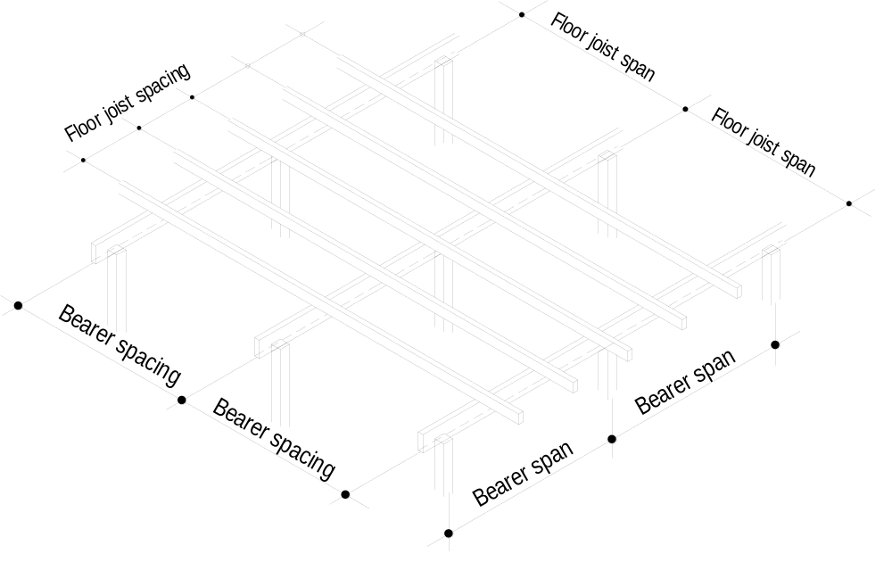
In cavity brick construction the floor members are generally supported from a reinforced concrete footing system at the walls and masonry dwarf walls where required in the centre of larger rooms

Figure 1 Relationship between span and spacing

Suspended single Floor Construction.

Single floor construction is used where the floor joists cannot be supported between their ends.
Deep Joisted Floors.

For the purpose of the National Timber Framing Code a deep joisted floor is a floor system in which the required joist size has a depth equal to or exceeding four times its breadth.
Information required selecting an upper floor joist size from the National Timber Framing Code.
- type of timber (will determine correct supplement)
- determine correct table - will be TABLE 21 S
- SPACING of floor joists (will be determined by type of flooring used)
- SPAN of floor joist.
Table 21S also states the maximum permissible cantilever length allowed for the various joist sizes.

Floor beams, which may be specified for, use in a suspended floor frame when large spans are required.
- HYSPAN LVL beams - laminated veneer lumber.
- HYBEAM plywood "I" beams - plywood web members with timber or LVL top and bottom flanges.
- Gangnail POSI-STRUT - timber top and bottom chords with "V" shaped folded metal web members.

Lateral restraint
When deep joists are used extra precautions must be taken to prevent any lateral movement such as tilting or twisting.
The Code nominates two different types of lateral restraint, which can be used; they are solid blocking and herringbone strutting.

Floor Framing Supported by masonry walling.
Where the ends of timber bridging joists abut a masonry wall and the floor is more than 1800 mm above the ground, the ends of joists may bear directly into wall pockets, provided there is at least 12 mm clear air space at the sides and ends of members and at least 75 mm solid bearing. In the case of deep joisted floors the ends of members bearing in the wall pockets must be splayed towards their tops so the wall structure is not affected in the event of collapse due to fire or overload.
(Look at Fig 3.4. in the National Timber Framing Code.)

